Learning Framework 1300 Signature Assignment

This assignment meets the THECB Core Objectives and the following Student Learning Outcomes:
Core Objectives:
- Critical Thinking Skills - To include creative thinking, innovation, inquiry, and the analysis, evaluation, and synthesis of information.
- Communication Skills - To include effective written, oral and visual communication.
- Empirical and Quantitative Skills - To include applications of scientific and mathematical concepts.
- Social Responsibility - To include intercultural competency, civic knowledge, and the ability to engage effectively in regional, national, and global communities.

Student Learning Outcomes:
- Describe the research and theory in the psychology of learning, cognition, and motivation.
- Identify learning styles and analyze various factors that impact learning.
- Describe different perspectives of learning and adapt to different learning environments.
- Demonstrate integration of basic study skills, critical thinking skills, and communication skills.
- Identify and use college resources.

Instructions:
Students will create an e-portfolio in Canvas by accessing their Account. An e-Portfolio is much like a PowerPoint with multiple pages. The e-Portfolio consists of six projects.

Eportfolio
Watch your Professor’s video on how to complete this assignment and set up an e-portfolio. It is located under the Signature Assignment module, which you can access from the How-to Information Quick Access point on the homepage of our Canvas classroom.

To prepare for Project 1, complete the following:
- Assess your time schedule for 1 week.
- Assess your current beliefs about your academic abilities (growth vs. fixed mind set) and confidence.
- Assess your current level of motivation (consider this weekly for multiple weeks over the duration of the course or daily for a week).
- Identify when you experience low levels of motivation.
What is causing the lack of motivation?
How are you responding to your lack of motivation?
How is it impacting your academic performance?
- Assess your current learning style. Take the “What is your Learning Style?” assessment by Education Planner by following the link here to educationplanner.org: http://www.educationplanner.org/students/self-assessments/learning-styles-quiz.shtml
- How do you currently study?
How do you monitor your knowledge about your courses?
How do you recognize when you are not learning what you should be learning?
What do you do about it?
Project 1. (meets SLO 1 – motivation, SLO 2, SLO 3, SLO 4)
Based on your assessments completed in the above preparation phase, develop a visual aid (this can be a model / diagram / table / chart) showing the following and using the terminology learned throughout the course:
- Record your time and commitment to studying (this could be in a planner).
- Record your learning style in a pie chart (include percentages – they should total 100%).
- Write a strategy that can be implemented to challenge any negative self-beliefs. The strategy when implemented would result in an improved mindset. Students are to use the course textbook.
- Write a strategy to motivate yourself when you lack drive concerning academics. Students are to use the course textbook.
- Write a strategy of how you will monitor your knowledge gained concerning what you are expected to learn. Students are to use the course textbook.
- Write a strategy of how you will recognize when you are not learning what is expected. How do you monitor your performance?
- Write a strategy that can be implemented to change your behavior when you recognize you are not learning what is expected.
- Go one step further to make what you are learning applicable in your career/job, write a description of how you would use the information learned from this course to teach a new employee at your work how to use these new learning skills to learn on the job. Students are to use the course textbook.
- In Project 1, students are to use written explanation of your visual aid using theories of learning, cognition and motivation and use terminology learned throughout the course for answers C - H using your course textbook to support your answers.

Project 2: (meets SLO 1 - psychology of learning, SLO 3, SLO 5)
- Make a list of the tools you currently use to help you study.
- Write a summary of your current study strategies.
- Do the following:
Complete the SQ3R (survey, question, read, recite, and review) reading strategy using an assignment from a course textbook in a course other than Learning Framework.
The purpose of this activity is to give students the opportunity to use the learning skills gained from this course, in other courses.
As evidence, students must provide the following:
  - A printed pdf copy of a minimum of 3 pages from the selected reading assignment used in the Survey and Read parts of the strategy.
  - Create a list of 5-7 questions and answers developed using the Question part of the strategy.
  - Choose a paragraph from the selected reading and rewrite it in your own words to demonstrate your understanding of the selected text for the Recite part of the strategy.
  - Highlight or underline main ideas in the reading assignment for the Review part of the strategy. This should be done on the printed copy from part a above.

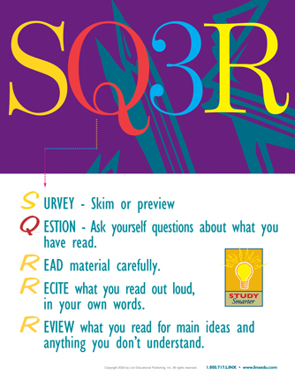

Project 3: (meets SLO3) Learning in different environments.
Instructions:
Show a page of notes with remarks in the margins explaining your notes. These must come from another course, not Learning Framework.
Provide two note-taking entries - one from a class lecture and one from an assigned reading.
Be sure to include the title of the textbook and the course name from which the lecture and assigned reading was chosen. Here is an example of what your finished product should look like.
Note: You can use the same assigned reading/textbook from Project 2.
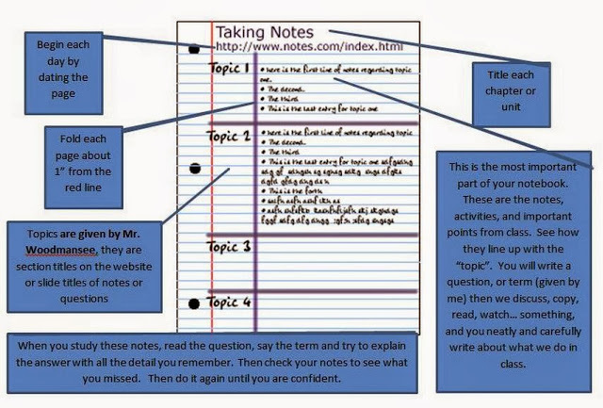
This Photo by Unknown Author is licensed under CC BY-SA-NC

Project 4: (meets SLO 3, SLO 4) Preparing for exams.
Instructions:
Develop a quiz with 10 questions that include both lower and higher levels of learning based on Bloom’s taxonomy.
The questions must include true / false, multiple choice, and essay questions.

Project 5: (meets SLO 3, SLO 4) Writing Papers and Assignments.
Instructions:
Develop an outline for a class paper from one of the courses you are currently enrolled in.
Explain how you would use the course textbook to develop your paper.

